newsletter
volume 10 issue 4 1 january 2012

‘Gotong Royong Utrecht’ Foundation
postal address: oudkerkhof 15 bis, 3512 GH Utrecht, the netherlands
email: info@gotong-royong-utrecht.nl
bank account: 84.21.36.932 (FORTIS)
reg.number chamber of commerce H30179877

1. From the board

First of all our best wishes for the new year that lies ahead of us!

Looking back at last year, we realize we did not do all that badly, compared to many other small development aid organizations who experienced a major decline. Many of you continued supporting us, we thank you very much for this! You inspire us to keep doing our work.
In the last three months we eliminated our deficits thanks to several very generous gifts. There is enough money now for a reasonably good start of the new year. We especially want to thank private sponsors like IJzebrand, Edwin and Lisette, Cecile, Paul and Margreet, Ria, Nadine, Yim Lan Pok, Lex and Arris. And institutional sponsors like Van Veenendaal-Bot, Louisa Stichting, ICCO/Impulsis in cooperation with the city of Utrecht, Kerk in Actie and a foundation that wishes to remain anonymous but who we thank through Aad. Fantastic.

2. Couleur locale

Because we now hold office in Yogyakarta on Java and no longer in Singaraja Bali, the nature of our daily activities has changed. On Bali we spent a lot of time on operational work in the children’s home and with the seniors. Here on Java we focus on volunteer management and the building of MCKs. In November we personally visited all 25 seniors receiving special weekly support, together with Sunardi, the coordinator of the senior citizens’ project. We witnessed the appalling conditions in which some of them are living and met people who are ever so grateful that there are Dutch sponsors caring for them, some of them even shed a tear. But tears were also shed because of the pain and hopelessness of their situation. If there is anyone who doubts the use of helping seniors, we gladly invite him or her to come with us on our visits. Our support might not be sustainable or self-supportive, but who cares? It is extremely necessary and highly appreciated.

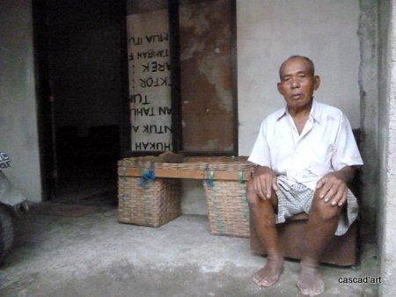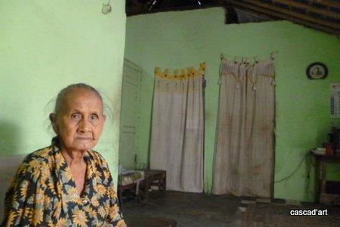

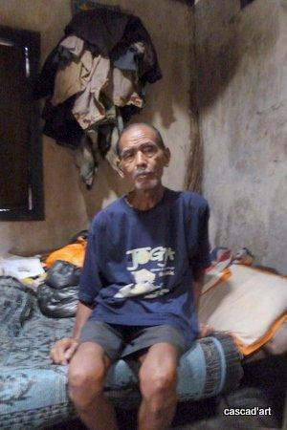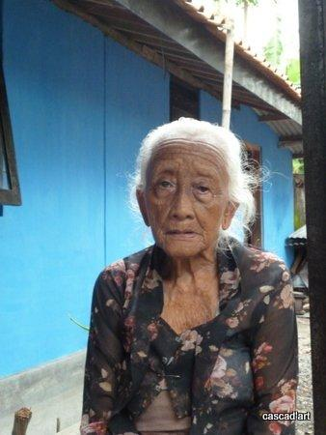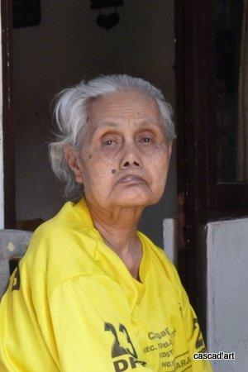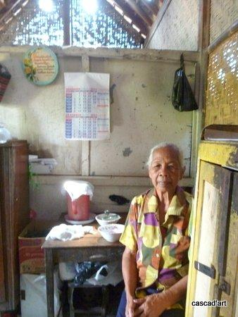

3. Project information

I. Bali: Widhya Asih III children’s home, Singaraja

The new computers (thanks to the Louisa Foundation) have arrived and were put to use with great enthusiasm. The children are proud they are allowed to work with state of the art computers.
They are doing well, we see cheerful faces and hear enthusiastic stories.
The home’s head office in Denpasar is looking for new foreign sponsors for scholarship funding. They have known for one and a half years now that our funding, which started five years ago as an emergency measure when the German sponsor Kinder Nothilfe stopped, is finite. This temporary support has lasted long enough now, it is time other parties and head office take their responsibility. We will keep supporting the children’s home on operational projects. And of course we guarantee to keep supporting the students until they graduate. The students are all doing very well. Only Sumi caused us some worries because she regularly got harassed on her way home from Art School at night, a long journey on her moped. We are glad she now found a boarding house she shares with several class mates near the school. Artana, who is studying on Bali (Art, design and teaching) will graduate one of these days.

II. Bali-Java: Scholarships

The first semester is finished; most children performed well, some very well, and a few are lagging behind a bit, sometimes because of illness or adjustment problems. In January, when the holidays are over, the circus of rolling out support will start again: making inventories, selecting, buying and handing out all clothing, books and materials needed.

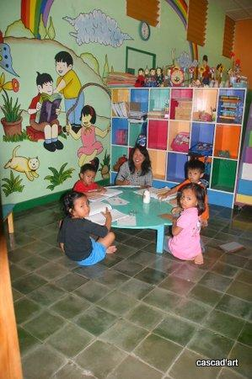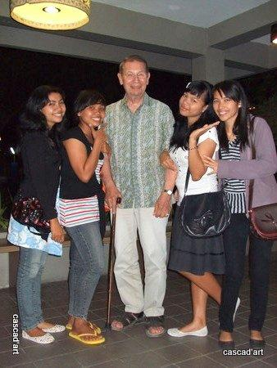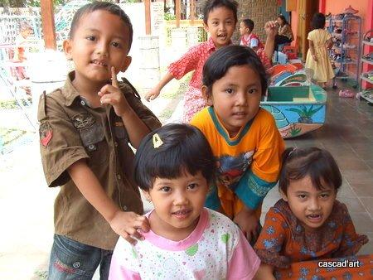

III. Bali-Java: Senior citizens & Medical Support

The past months we visited all seven seniors’ groups (one on Bali and six in Yogyakarta. We did this several times, to the delight of everyone (not in the least ourselves). There is much need for medical support. We visited the special seniors (the group of 25 in need of weekly support) without any prior announcement. As a result of these visits we made some changes in the contents of the parcels (food, medicine) they receive. And we moved two participants to the regular monthly support, because we decided others are more in need of special care. One of them is living with a son and a grandson who both got better paid jobs and are now able to take care of grandmother.

IV. Java: MCKs (public bath/washrooms)

In October and November we finished two MCKs (Gunung Moyo and the second one in Botokan RT2) and started a third one (Agrosari). All was done according to the right procedures and rituals (even on Java it includes flower offerings and holy water). We visited several locations and a few proved to be suitable to build an MCK in the (near) future. We were impressed by the motivation and personal contribution of the villagers during the construction process. They are certainly not passive recipients.

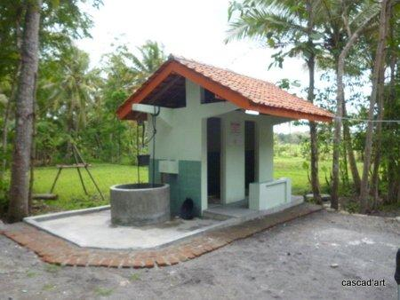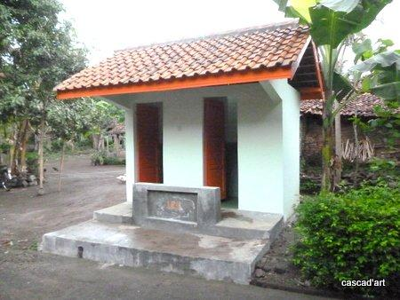

4. News from our sponsors

Jacqueline visited us in October in Yogyakarta and saw several projects. She advises everyone to come and see for themselves (but preferably not all at once).
Lex and his family donated the church collection at their father’s funeral to us, we are very thankful for this. And our ambassadors Edwin and Lisette threw a party for Lisette’s birthday and asked all of their friends and relatives for a donation because they are saving money to give us an MCK. A great initiative!

5. Social networks

Project videos can be found at You tube: http://www.youtube.com/user/GotongRoyongUtrecht:
- Widhya Asih children’s home; with thanks to Anne from Alkmaar!
- the nursery in Yogyakarta
- Ibu Suresemi (a Parkinson’s patient receiving our support)
If you are a Facebook user, please link our website to your Facebook by using the ‘thumbs up’ symbol on our site. Your Facebook friends might be interested in supporting us!

6. Sponsor possibilities

- the scholarship programme: one scholarship is € 60 (primary school), € 95 (junior high school) or
€ 125 (senior high school) a year and can start any time during the year,
- sponsoring a child of the children’s home for € 12 a month (€ 36 a quarter or € 144 a year) for complete sustenance,
- the support of a senior (60 plus) for € 10 a month (especially for vitamins, minerals and medical care). This is € 30 a quarter or € 120 a year.

Of course you can also send us a free gift and leave the spending to us.

7. Gifts

Gifts are more than welcome at our bank account in Holland (Fortis): 84.21.36.932 (for the attention of Stichting Gotong Royong - Utrecht). For people who want to donate and who are living outside Holland, please contact us by e-mail so we can find a proper method of transaction for your donation.

8. Email & website

If you want to let us know something, if you have feedback, if you want to ask something, please send us an email: info@gotong-royong-utrecht.nl

And have a look at our website, with many photos of our projects:
www.gotong-royong-utrecht.nl

